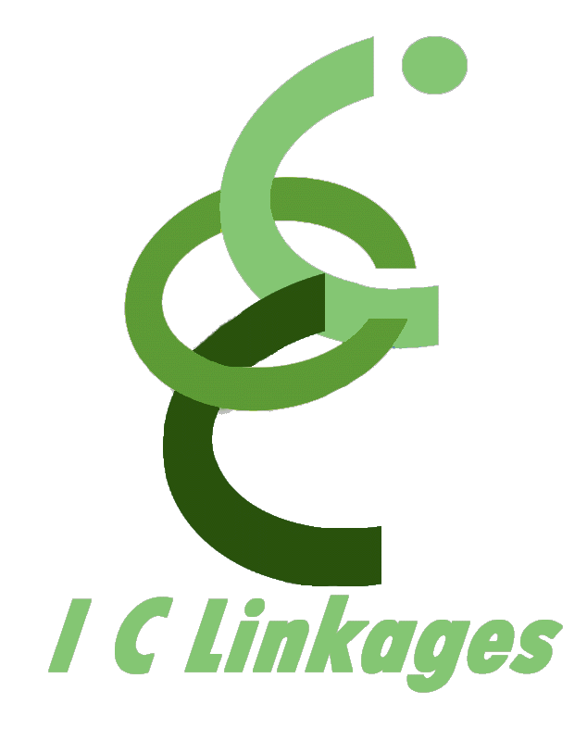
P.O. Box 696 Olney, Maryland 20830-0696 301.260.0778 (o) 301.260.0779 (f)
info@iclinkages.com

FOR IMMEDIATE RELEASE
Contact: Patricia Green
301.260.0778 – office 301.260.0779 – fax
patricia.green@iclinkages.com

Author Underscores Importance of Strong Families to Global Community through Children’s Books

Baltimore Native Offers Stories from Her Mother’s Childhood in Storybooks

BALTIMORE, MD, June 30, 2009 -- “A strong nation is made up of strong families,” according to President Barack Obama. The President identified Family as a key issue of his administration and pledged to invest in public school education to “[prepare] all children for success in the new global workplace.” Children’s book writer, Lisa Douglass, understands the significance of the President’s message and puts it to practice in a uniquely educational way that appeals to children, their parents, and educators.

A Baltimore native, Lisa has many talents, one of them being author of a series of children’s books that promote strong families. A College of Notre Dame of Maryland political science graduate who earned a masters degree in engineering science from Loyola College, Lisa’s books are based on stories her mother told her when Lisa was a child, stories from her mother’s childhood in a Baltimore row house. These recollections inspired Lisa to create the Gwendolyn Baloney Lomax book series. Parents, teachers, children, and other avid readers of children’s books can meet Lisa and get signed copies of her books at the Baltimore Book Festival this coming September.

“My books have a strong social science theme, a natural extension of my background in history and political science studies,” shares Lisa. Five-year-old Gwendolyn Baloney, the main character in Lisa’s three books, takes the reader to her world, one of wanting to go to school, visiting the south, and going on a movie date with her sister and her sister’s boyfriend. “In today’s fast-paced world, Baloney Books™ depicts a simpler and happier life and teaches children lasting values,” Lisa adds.
-more-

“Offering stories that help to reinforce basic instructional and performance objectives of the Social Studies curriculum is my contribution to furthering what I believe to be the purpose of every citizen: understanding how each of us is responsible for relating the past to the present; recognizing changes and similarities in culture, and fostering young thinkers who contribute to building strong global communities through understanding rules, rights, and responsibilities in the family microcosm,” Lisa concludes.

Baloney Books™ offers instructional guides for the Kindergarten Grade Social Studies curriculum, focusing on the study of children and their immediate environment. Individual, family, and community themes are highlighted in the companion guides for the book series, available for download at http://www.baloneybooks.com/.

The series has been added to the Baltimore County Public Library’s collection and catalog. Lisa is available for readings and Baloney Books™ can be purchased online at http://www.baloneybooks.com/. Lisa’s email address is lisa@baloneybooks.com.
Visit the Baloney Books™ MySpace page at http://www.myspace.com/baloneybooks.
Sign up to become a Facebook Fan at http://www.facebook.com/pages/Baloney-Books/40940843876. For media interviews and queries, contact Patricia Green at 301.526.1089.

###

