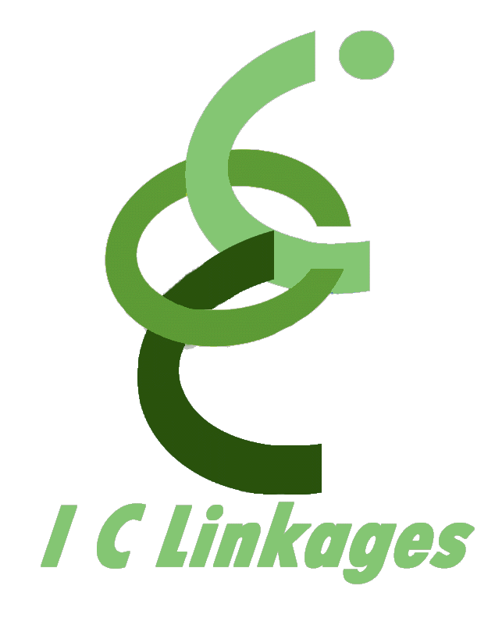
P.O. Box 696 Olney, Maryland 20830-0696 301.260.0778 (o) 301.260.0779 (f)
info@iclinkages.com

FOR IMMEDIATE RELEASE
Contact: Patricia Green
301.260.0778 – office 301.260.0779 – fax
patricia.green@iclinkages.com

Gwendolyn Baloney Lomax Goes to Radio
Children’s Book Author Launches Saturday Morning Children’s Program

August 31, 2009, Washington, DC -- Lisa Douglass, founder of Baloney Books™ and author of the Gwendolyn Baloney Lomax book series, takes her creations to radio, starting Saturday, September 5, from 7:30 a.m. - 8:00 a.m., on Washington, DC's WOL-AM (1450). Children, their parents, and teachers can enjoy the 30-minute, 16-week educational program that includes a story, vocabulary development, and a chat about some of the story themes. Designed for kindergarten through third grade audiences, Lisa's radio show will reinforce classroom subject matter.

“I am thrilled to be taking Baloney Books™ to radio listeners,” shares Lisa, the daughter of an educator and for whom the Gwendolyn Baloney Lomax book series is based. Each program will cover social studies topics such as rules, rights, responsibilities, geography, economics, time, sequential ordering of activities, and language arts skills.
The program will also be offered LIVE on the web through streaming Internet radio, affording the Baloney Books™ Reading Room a global audience. Log on to WOLDCNews.com and LISTEN LIVE! For media interviews and queries, contact Patricia Green at 301.526.1089.

Editor’s Note: The Gwendolyn Baloney Lomax book series is based on stories Lisa’s mother shared with her about childhood, as the youngest of eight siblings, in her Baltimore row house and neighborhood. Parents, teachers, children, and other avid readers of children’s literature can meet Lisa and get signed copies of her books at the Baltimore Book Festival this coming September. More information on Baloney Books™ can be found online at http://www.baloneybooks.com/.

###

